**Union 합집합**

1. **Select * from sample71_a;**
2. **Select * from sample71_b;**
3. **Select * from sample71_a union**

**select * from sample71_b;**

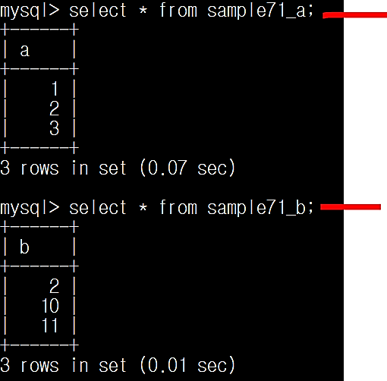

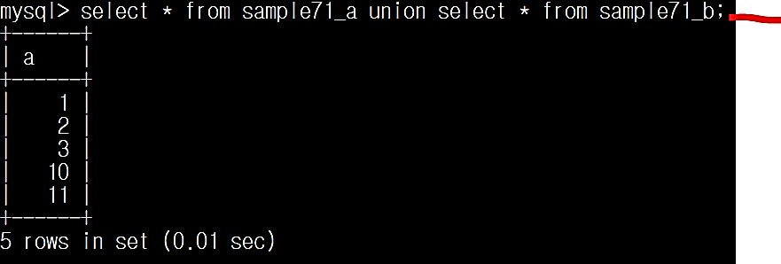

**Union🡪 select 명령의 실행결과를 합집합으로 계산**

1. **Select * from sample71_a;**
2. **Select * from sample31;**
3. **Select * from sample71_a union Select * from sample31;**
4. **Select * from sample71_a union Select age from sample31;**

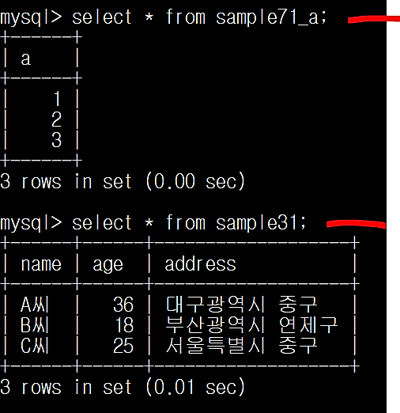



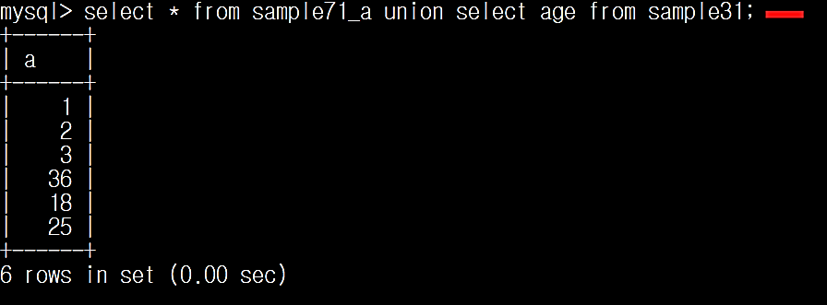

**열 구성이 다른 테이블을 Union으로 묶을 수 없다**

**열을 따로 지정하여 열 개수와 자료형을 맞추면 가능함**

1. **Select * from sample71_a union Select age from sample31;**
2. **Select age from sample31 union Select * from sample71_a;**

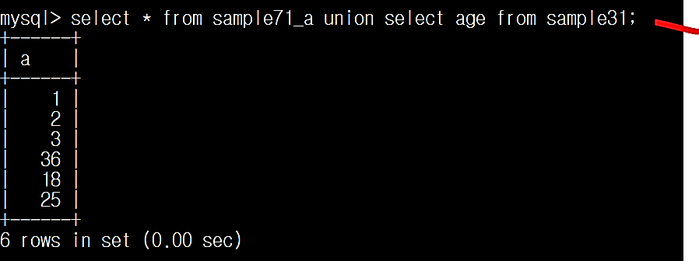

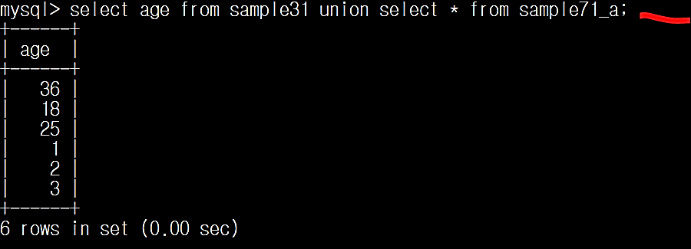

**열 나열 순서에 따라 합집합 결과 나열 순서가 달라짐**